**Liberia Vaccination Digital Platform**

MoH Mobile App

**Software Requirement Specifications (SRS)**

**Introduction** **2**

**Purpose** **2**

**Intended Audience** **2**

**Problem Statement** **2**

**Methodology** **2**

**Functional** **3**

**Non-Functional** **5**

**API’s Call** **6**

**Architecture or mockups** **7**

**Variables to consider in an EIR** **7**

# **Introduction**

Liberia MoH Mobile App is an android version with information including the vaccine and testing status. Fit has offline capabilities. The system can synchronize data between both P2P and APIs offline/online automatically. Using the Vaccine Inventory option, the platform can set vaccine targets per county, record vaccines given by facility as well as record vaccine wastage at county and national levels. Additionally, it can generate dynamic report reports and vaccine status. This platform will incorporate all vaccines in the routine immunization program, their schedules, routes of administration, target groups, and ages. (Duration: Two months to include requirement gathering and development). The Platform will be made interoperable with different systems. Software development life cycle will be considered and knowledge transfer will be provided through ToT.

# **Purpose**

However, the need for additional features has been recognized for improved enhancement of the digital system by

* Adding additional features, to the existing Covid-19 Vaccine Platform to adapt to current needs worldwide vaccine certificate requirements.
* Integrate and improve immunization program management.
* Make a system user-friendly for stakeholders at all levels
* Make fully interoperable the vaccine digital platform (DHIS2, eLMIS, OpenMRS, etc).
* Generate Digital certificates using standardized international and regional guidelines (EU)

# **Intended Audience**

The SRS document is intended for anyone who wants to have a holistic understanding of the system and tries to give a clear idea to decision-makers on what requirements the software tries to meet. The SRS is also useful for the design and development of the application and is considered a constitutional document that has to be followed for any further development of the software. Ministries of health can understand the use of the application by reading this document. External testers can perform functional testing by understanding the expected results of the application.

# **Problem Statement**

A digital COVID-19 vaccination platform was deployed six months ago and has mitigated most of the challenges associated with using a paper-based data system. However, Different international standards triggered the idea to improve the existing immunization system by adding additional features, an offline model as well as integration with other systems.

* **Gap analysis (Source)?**
* **Business Process (Source)?**

# **Methodology**

The platform is developed on the principles of Xtreme Programming (XP) which includes simplicity, communication, feedback, and courage. Simple design and continuous refactoring through feedback is the process followed for the development and implementation of the system.

Undertaken Tasks:

* Gathering information
* Understanding the system and user requirements
* System Design: User-friendly portal framework to be used by all stakeholders
* System Implementation: Implementing the different components and subsystems
* Unit Testing: Testing each subsystem independently
* System Integration: Integration of different subsystems to form the whole system.
* System Testing: Testing the system as a whole
* Test Specification: Submission of a full report of the known bugs and errata of the system.

The below requirements were gathered during the various interviews with programs and end users. Their wish list was translated into implementable features following the business process at each point of service care in the health facility.

# **Functional**

|  |  |  |  |  |
| --- | --- | --- | --- | --- |
| **Id** | Functional requirement unique Id | | | |
| **Requirement** | The name of the requirement | | | |
| **Business Mapping** | Mapped Business process diagrams | | | |
| **Description** | The description of the requirement | | | |
| **Mandatory/ Desired** | This column indicates if the client considers the requirements mandatory or desired. Mandatory requirements should be prioritized. • Desired requirements are represented by” D” • Mandatory requirements are represented by “M” | | | |
|  | | | | |
| **Id** | **Requirement** | **Business** **Mapping** | **Description** | **Mandatory** **/Desired** |
| **FRPR0** | Contact Number |  | Click on the number and direct Dial | M |
| **FRPR1** | Email |  | click on email address direct open the msg text field with option to attach send and discard | M |
| **FRPR2** | Travel Guidelines |  | List all related travel policies and procedures including Covid-19. | M |
| **FRPR3** | Travel Guidelines |  | Option to download if applicable | M |
| **FRPR4** | Testing Status |  | When click, open a new tab (Left on architecture) | M |
| **FRPR5** | Testing Status |  | Allow Client to login using username and password | M |
| **FRPR6** | Testing Status |  | Call the Covid-19 platform through APIs (Refer to **API’s** Call section) | M |
| **FRPR7** | Testing Status |  | Display information related to Testing Status | M |
| **FRPR8** | Testing Status |  | Generate the certificate with standardized worldwide requirement (EU, Regional, etc) | M |
| **FRPR9** | Testing Status |  | Allow client to download the certificate include OR code (https://commission.europa.eu/publications/key-documents-related-digital-covid-19-certificate_en) | M |
| **FRPR10** | Vaccination Status |  | Open a new tab (Left on architecture) | M |
| **FRPR11** | Vaccination Status |  | Allow Client to login using username and password | M |
| **FRPR12** | Vaccination Status |  | Call the Covid-19 platform through API’s (Refer to **API’s Call** section) | M |
|  | Vaccination Status |  | Display information related to Covid-19 Vaccines status | M |
| **FRPR13** | Vaccination Status |  | Generate the certificate with standardized worldwide requirement (EU, Regional,etc) | M |
| **FRPR14** | Vaccination Status |  | Allow client to download the certificate include OR code (https://commission.europa.eu/publications/key-documents-related-digital-covid-19-certificate_en) | M |
| **FRPR15** | Services |  | Any information to help client during pandemic | M |
| **FRPR16** | Cases |  | Section containing most recent number of (Pandemic) confirmed cases in Liberia | M |
| **FRPR17** | Recovered |  | Section containing most recent number of a (Pandemic) confirmed Recovered in Liberia | M |
| **FRPR18** | Death |  | Section containing most recent number of a (Pandemic) confirmed Death in Liberia | M |
| **FRPR19** | Staff Only |  | Secction reserved for Health care provider only | M |
| **FRPR20** | Staff Only |  | Authenticate using DHIS2 vaccination username and password | M |
| **FRPR21** | Staff Only |  | 2 Factors authentication for security | M |
| **FRPR22** | Staff Only |  | Connect and display the Vaccination portal (Refer to Archtecture) | M |
| **FRPR23** | Vaccination portal |  | Allow to search client by ID, Phone, Names via Vaccination registry | M |
| **FRPR24** | Vaccination portal |  | Interoperability with eLMIS for stoch requisition | M |
| **FRPR25** | Vaccination portal |  | Ability to display different reports (Dinamic and predefined) | M |
| **FRPR26** | Vaccination portal |  | Recording individual demographics informations | M |
| **FRPR27** | Vaccination portal |  | Generate UPID, and system ID | M |
| **FRPR28** | Vaccination portal |  | Data entry of vaccine related information | M |
| **FRPR29** | Vaccination portal |  | Ability to set next aopintment randervous | M |
| **FRPR30** | Vaccination portal |  | Abiity to notify the client about their ID and next visit date | M |
| **FRPR31** | Vaccination portal |  | COmplete automatically create visit or event and trigger notification message through gateway | M |
| **FRPR32** | Vaccination portal |  | Sync option to allow pear to pear (P2P) data exchange via offline/online or direct to oroduction server | M |
| **FRPR33** | Choose Vaccine* |  | Mandatory field listing all Vaccines (Covid, Rootine and SIV) | M |
| **FRPR24** |  |  |  | M |
| **FRPR35** |  |  |  | M |
| **FRPR36** |  |  |  | M |

# **Non-Functional**

|  |  |  |  |  |
| --- | --- | --- | --- | --- |
| **Id** | Non Functional requirement unique Id | | | |
| **Requirement** | The name of the requirement | | | |
| **Business Mapping** | Mapped Business process diagrams | | | |
| **Description** | The description of the requirement | | | |
| **Mandatory/ Desired** | This column indicates if the client considers the requirements to be mandatory or desired. Mandatory requirements should be prioritized. • Desired requirements are represented by” D” • Mandatory requirements are represented by “M” | | | |
|  | | | | |
| **Id** | **Requirement** | **Business** **Mapping** | **Description** | **Mandatory** **/Desired** |
| NFRPR0 | Search for Patient |  |  | M |
| NFRPR1 | Add Patient Details |  |  | M |
|  | **User Requirements** |  |  |  |
| NFRPR2 | User friendliness |  |  | M |
|  | **Technical Requirements** |  |  |  |
| NFRPR4 | Accessibility |  |  | M |
| NFRPR5 | Interoperability |  |  | M |
| NFRPR6 | Scalability |  |  | M |
| NFRPR6 | Extensibility |  |  | M |
|  | **Efficiency requirement** |  |  |  |
| NFRPR9 | Performance |  |  | M |
| NFRPR10 | Capability |  |  | M |
| NFRPR11 | Availability |  |  | M |
|  | **Development requirement** |  |  |  |
| NFRP13 | Software cost |  |  | M |
| NFRPR14 | Input data Cost |  |  | M |
| NFRPR15 | Labor Intensity |  |  | M |
| NFRPR16 | Documentation |  |  | M |

# **API’s Call**

**VACCINATION APIs:** Connect to existing Covid-19 platform(s). API authentication Credentials:

* username: “api_user_au”
* password: " "

|  |  |
| --- | --- |
| **URL for using NID: /api/vaccine_records/?national_id=" "** | **URL for using UniqueID: /api/vaccine_records/?unique_id=””** |
| Sample Response:  [      {          "id": 0,          "phone_number": "",          "first_name": "",          "last_name": "",          "national_id": "",          "vaccine_name": "",          "vaccination_date": "",          "dose_number": "DOSE3",          "vaccination_status": "Completed 3rd dose"      },      {          "id": 1,          "phone_number": "",          "first_name": "",          "last_name": "",          "national_id": "",          "vaccine_name": "",          "vaccination_date": "",          "dose_number": "DOSE2",          "vaccination_status": "Completed 2 doses"      },      {          "id": 2,          "phone_number": "",          "first_name": "",          "last_name": "",          "national_id": "",          "vaccine_name": "",          "vaccination_date": "",          "dose_number": "DOSE1",          "vaccination_status": "Completed 1st Dose"      }  ] | Sample Response:  [      {          "id": 0,          "phone_number": "",          "first_name": "",          "last_name": "",          "national_id": "",          "vaccine_name": "",          "vaccination_date": "",          "dose_number": "DOSE2",          "vaccination_status": "Completed 2 doses"      },      {          "id": 1,          "phone_number": "",          "first_name": "",          "last_name": "",          "national_id": "",          "vaccine_name": "",          "vaccination_date": "",          "dose_number": "DOSE1",          "vaccination_status": ""      },      {          "id": 2,          "phone_number": "",          "first_name": "",          "last_name": "",          "national_id": "",          "vaccine_name": "",          "vaccination_date": "",          "dose_number": "DOSE3",          "vaccination_status": "Completed 3rd dose"      }  ] |

# 

# **Architecture or mockups**

**Proposal from EPI**

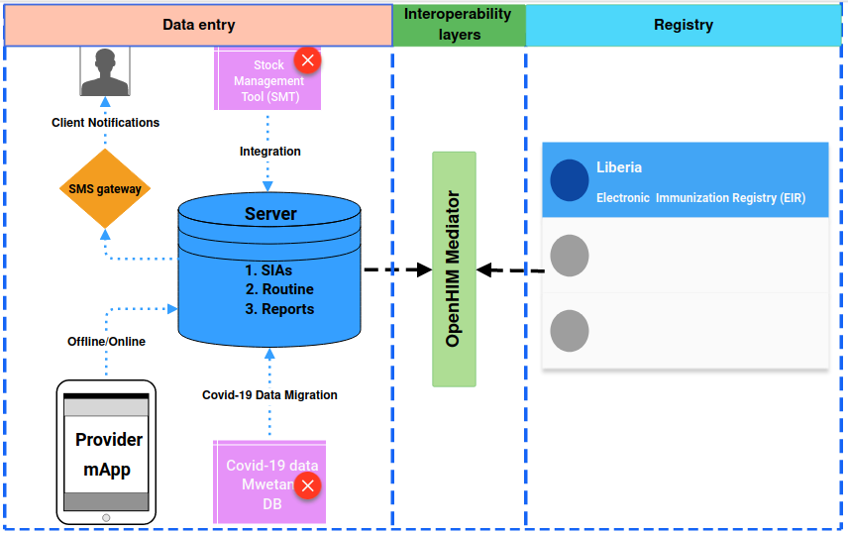

**Source:** https://app.moqups.com/unsaved/89e5c8fe/edit/page/acd05e6be

# **Variables to consider in an EIR**

|  |  |  |
| --- | --- | --- |
| **CATEGORY** | **VARIABLES** | **PURPOSE** |
| Demographic data  of the user or  vaccine recipient of the user or vaccine recipient | Unique identifier of the vaccine recipient, if available in the country (e.g., national ID card,  social security number, national health system number, passport, or similar ID) | These variables are necessary for unique identification of  each vaccine recipient and thus allow follow-up of individual  immunization status. Furthermore, these variables allow  the generation of different analyses, e.g., of data quality,  inequalities, and coverage by place of residence, and enable  active search of unvaccinated individuals or defaulters as  required. On the other hand, they also allow the implementation  of monitoring activities and vaccine reminders through  telephone calls and/or text messages. |
| First name, middle name, last name(s) |
| Date of birth |
| Place of birth (health facility, city) |
| Sex |
| Contact telephone number (landline and/or mobile)b |
| Home address |
| Municipality (or similar) of residence |
| Landmarks or directions to user’s place of residence |
| Coordinates or georeferences to user’s place of residence |
| Nationality |
| E-mail |
| Occupation |
| Status (active/inactive, e.g., in case of migration or death) |  |
| Parent or legal  guardian of vaccine  Recipient | Complete name and surname of the mother and/or father and/or  guardian of the patient | These variables enable complete identification of the  individual, especially of children, and allow implementation of  monitoring activities and reminders through telephone calls  and/or text messages |
| Phone number (landline and/or mobile) |
| Municipality of residence |
| Unique ID of patient’s parents (e.g., national ID card, social security number) |
| Immunization  activity and  description of the  biologic agent | Biologic | Necessary for establishing a detailed history of the  immunization activity. This provides a complete vaccine  history for each individual and thus allows follow-up in  accordance with the established immunization schedule.  On the other hand, data related to the biological agent  or vaccine itself allow various analyses of data quality,  stock traceability, reasons for not vaccinating (e.g.,  contraindications vs. refusal of certain vaccines), and  monitoring of ESAVIs. |
| Dose |
| Date of administration |
| Batch number |
| Batch expiration date |
| Commercial formulation (e.g., hexavalent, pentavalent) |
| Manufacturer |
| Condition of the vaccine recipient, if applicable |
| Reason for not vaccinating (includes contraindications, history of ESAVI, etc.) |
| Vaccination-emergent adverse reactions (reported ESAVIs) |
| Immunization  strategy and  Technique | Name and address of health facility | These variables provide a detailed background of the facility  where the vaccine was administered and who administered  it and allow analyses of productivity of the immunization  strategy used. |
| Identification code of health facility |
| Type of health facility |
| Sector (public, private, or other) |
| Type of strategy (intramural, extramural, etc.) |
| First name, last name, and ID number (or assigned code) of the vaccinator |